Computer Laboratory Assignment A1 Report

Symplectic Euler

The Differential Equation
The Symplectic Euler method provides a numerical solution for the system $\vec{u}={\left(u_{1},u_{2}\right)}^{T}$, expressed in component form as:

 | $$u_{1,k}=u_{1,k-1}+hu_{2,k-1}, u_{1,0}=1$$ | (1)

 | $$u_{2,k}=u_{2,k-1}-hω^{2}u_{1,k}, u_{2,0}=0$$ | (2)

, where $k=1,2,…,N$. In the lab, $h=0,1$ and $N=100$ are given.

Analytic solution
Equation (2) can be reformulated using (1) as follows:

$$u_{2,k}=u_{2,k-1}-hω^{2}u_{1,k} \\ =u_{2,k-1}-hω^{2}\left(u_{1,k-1}+hu_{2,k-1}\right) \\ =hω^{2}u_{1,k-1}+u_{2,k-1}-h^{2}ω^{2}u_{2,k-1} \\ =-hω^{2}u_{1,k-1}+(1-h^{2}ω^{2})u_{2,k-1}$$

 | $$u_{2,k}=-hω^{2}u_{1,k-1}+(1-h^{2}ω^{2})u_{2,k-1}$$ | (3)

By combining (1) and (3), the system can be expressed in matrix-vector form:

 | $${\vec{u}}_{k}=A∙{\vec{u}}_{k-1}=\left(\begin{matrix}1 & h \\ -hω^{2} & 1-h^{2}ω^{2}\end{matrix}\right)\left(\begin{matrix}u_{1,k-1} \\ u_{2,k-1}\end{matrix}\right)$$ | (4)

, where $A$ is the 2x2 coefficient matrix of ${\vec{u}}_{k-1}={\left(u_{1,k-1},u_{2,k-1}\right)}^{T}$.

The initial value vector is given by

 | $${\vec{u}}_{0}= \left(\begin{matrix}u_{1,0} \\ u_{2,0}\end{matrix}\right)=\left(\begin{matrix}1 \\ 0\end{matrix}\right)$$ | (5)

Numerical solution
The simulation of the harmonic oscillator using the Symplectic Euler method is presented in Figure 1. The figure consists of three plots that illustrate different aspects of the system’s behavior:

The top plot shows the time evolution of the system’s variables $u_{1}$ and $u_{2}$ (denoted as $y_{1}$ and $y_{2}$ in MATLAB), representing the solution trajectories. The trajectories appear as stable sinusoidal oscillations, reflecting the expected periodic motion of the harmonic oscillator.

The middle plot presents the phase portrait, illustrating the oscillator’s cyclic behavior with a characteristic elliptic shape. Since the phase portrait forms a closed loop, the system returns to the system’s initial conditions, as demonstrated in the trajectory (top) plot. As the orientation of the phase portrait is determined by the eigenvalues of the coefficient matrix, the slight leftward tilt of ellipse indicates a phase difference between variables $u_{1}$ and $u_{2}$.

The bottom plot depicts the variation of the exact energy over time, demonstrating the energy conservation properties of the numerical method. The relatively stable sinusoidal oscillations illustrate the Symplectic Euler method’s effectiveness in preserving the system’s total energy.

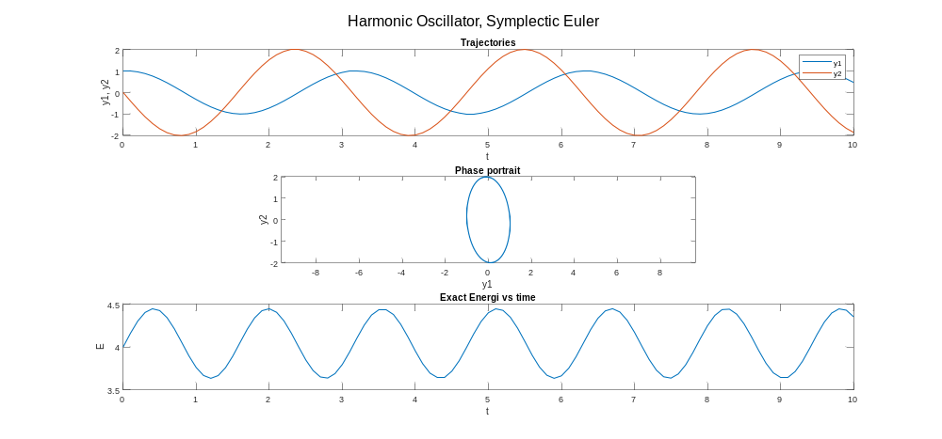
Figure 1. Simulation of a harmonic oscillator using the Symplectic Euler method.

MATLAB code: Symplectic Euler
%% Symplectic Euler
clc, clear, close all

% parameters
h = 0.1;
N = 100;
omega = 2;

% IC
y=[1,0]'; t=0;

A=[1, h; -h*omega^2, (1-h^2*omega^2)];
eig(A)

Y=[y']; T=[t]; E=[omega^2];
for k=1:N
y=A*y;
Y=[Y;y'];
t=t+h;
T=[T;t];
E=[E;omega^2*(y(1))^2+(y(2))^2];
end

figure;
subplot(3,1,1)
plot(T,Y, "LineWidth", 1); xlabel('t'); ylabel('y1, y2'); title('Trajectories')
legend('y1', 'y2');

subplot(3,1,2)
plot(Y(:,1),Y(:,2), "LineWidth", 1)
axis('equal'); xlabel('y1'),ylabel('y2'); title('Phase portrait')

subplot(3,1,3)
plot(T,E, "LineWidth", 1); xlabel('t'); ylabel('E'); title('Exact Energi vs time')
sgtitle('Harmonic Oscillator, Symplectic Euler')

Midpoint method

Analytic solution
The Implicit Midpoint Method is defined as:

 | $${\vec{u}}_{k}={\vec{u}}_{k-1}+hA\left(\frac{{\vec{u}}_{k}+{\vec{u}}_{k-1}}{2}\right)$$ | (6)

, where $k=1,2,…,N$, and $A$ is a 2x2 coefficient matrix. In the lab, $h=0,1$ and $N=100$ are given.

By rearranging (6), the solution ${\vec{u}}_{k}$ can be isolated:

$${\vec{u}}_{k}={\vec{u}}_{k-1}+hA\left(\frac{{\vec{u}}_{k}+{\vec{u}}_{k-1}}{2}\right) \\ {\vec{u}}_{k}=\left(\frac{hA}{2}\right){\vec{u}}_{k}+ {\vec{u}}_{k-1}+\left(\frac{hA}{2}\right){\vec{u}}_{k-1} \\ {\vec{u}}_{k}-\left(\frac{hA}{2}\right){\vec{u}}_{k}={\vec{u}}_{k-1}+\left(\frac{hA}{2}\right){\vec{u}}_{k-1} \\ \left(I-\frac{hA}{2}\right){\vec{u}}_{k}=\left(I+\frac{hA}{2}\right){\vec{u}}_{k-1}$$
$${\vec{u}}_{k}={\left(I+\frac{hA}{2}\right)}/{\left(I-\frac{hA}{2}\right)}{\vec{u}}_{k-1}$$

, where the coefficient matrix $A$ and 2x2 identity matrix are given by:

$$A= \left(\begin{matrix}0 & 1 \\ -ω^{2} & 0\end{matrix}\right)$$

$$I= \left(\begin{matrix}1 & 0 \\ 0 & 1\end{matrix}\right)$$

Numerical solution
The simulation of the harmonic oscillator using the Midpoint method is presented in Figure 2. The figure consists of three plots that illustrate different aspects of the system’s behavior. Overall, the Midpoint Method ensures long-term stability and is well-suited for oscillatory systems, such as the harmonic oscillator.

The top plot shows the time evolution of the system’s variables $u_{1}$ and $u_{2}$ (denoted as $y_{1}$ and $y_{2}$ in MATLAB), representing the solution trajectories. The trajectories appear as stable sinusoidal oscillations, reflecting the expected periodic motion of the harmonic oscillator.

The middle plot presents the phase portrait, forming a nearly perfect elliptical orbit, indicating accurate preservation of system dynamics. Since the phase portrait forms a closed loop, the system returns to the system’s initial conditions, as demonstrated in the trajectory (top) plot. Not only does the system periodically return to the initial conditions, indicating energy conservation, but also the real parts of the eigenvalues are zero, which is why the ellipse appears vertically.

The bottom plot depicts the variation of the exact energy over time, highlighting the energy conservation properties of the numerical method. The energy remains nearly constant with a extremely slight decrease, demonstrating the method’s symplectic nature, numerical stability, and superior energy conservation.

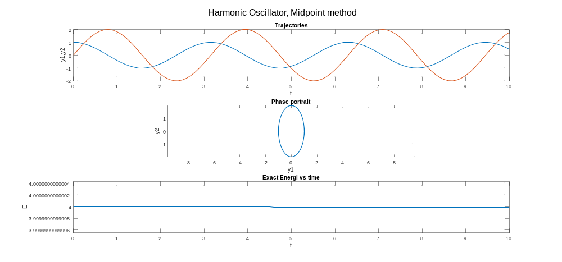
Figure 2. Simulation of a harmonic oscillator using the Implicit Midpoint Method.

MATLAB code: Midpoint method
%% Midpoint method
clc, clear, close all
% parameters
h = 0.1;
N = 100;
omega = 2;
%IC
y=[1,0]';t=0;

A=[0, 1; -omega^2, 0];
eig(A)

Y=[y'];T=[t];E=[omega^2];
for k=1:N
y=((eye(2) + (h/2)*(A))\(eye(2) - (h/2)*(A)))*y;
Y=[Y;y'];
t=t+h;
T=[T;t];
E=[E;omega^2*(y(1))^2+(y(2))^2];
end

figure;
subplot(3,1,1)
plot(T,Y, "LineWidth", 1); xlabel('t'); ylabel('y1,y2'); title('Trajectories')
legend('y1', 'y2');

subplot(3,1,2)
plot(Y(:,1),Y(:,2), "LineWidth", 1); axis('equal'); xlabel('y1'); ylabel('y2'); title('Phase portrait')

subplot(3,1,3)
plot(T,E, "LineWidth", 1); xlabel('t'); ylabel('E'); title('Exact Energi vs time')
sgtitle('Harmonic Oscillator, Midpoint method')

Verlet’s method

Numerical solution
The simulation of the harmonic oscillator using the Verlet’s method (a central difference of the second order) are presented in Figure 3 and 4. A supplement condition was provided at the start of the time-stepping to approximate the derivatives. Both Figure 3 and 4 consist of three plots that illustrate different aspects of the system’s behavior. The plots in Figure 3 are described as follows:

The top plot shows the time evolution of the system’s variables $u_{1}$ and $u_{2}$ (denoted as $y_{1}$ and $y_{2}$ in MATLAB), representing the solution trajectories. The sinusoidal oscillation of $u_{2}$ displays noticeable distortion near the end.

The middle plot presents the phase portrait, forming a nearly elliptical trajectory, demonstrating good energy preservation. However, deviations show towards the end. The phase portrait has a segment indicating a sudden change of direction, which can be due to either the input of $y_{1,1}$, i.e., the first element (approximation) in the $u_{1}$ vector, causing a disturbance or stiffness in the system.

The bottom plot shows the total energy over time, which remains stable but shows an artifact near the end, possibly due to boundary effects or accumulated numerical errors. This suggests potential issues with step-size handling or numerical precision in long-term simulations. Upon investigation of the energy vector elements in MATLAB, the energy drops at $t_{end}$, i.e., the last timestep.

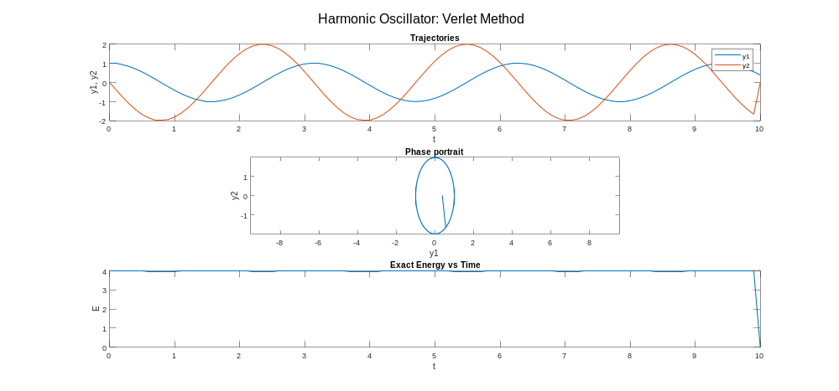
Figure 3. Simulation of a harmonic oscillator using the Verlet Method.

The reason for the artifact is because of a limitation of the numerical approximation method. In the numerical implementation in MATLAB, the last element of $u_{2}$ remains zero not due to numerical approximation—since no approximation of $u_{2}$(k) for $k=N+1$ has been made—but rather a consequence of the iteration structure. As can be seen in the code, $u_{2,k}$ partially depends on $u_{1,k+1}$ at each iteration. Since both vectors, $u_{1}$ and $u_{2}$ are defined from 0 to $N$, the final iteration of $u_{2}$, i.e., $u_{2,N}$, requires $u_{1,N+1}$, which is not defined. Consequently, the for-loop runs only up to $k=N$, leaving $u_{2,N+1}=u_{2}\left(N+1\right)$ unchanged from its initial definition. Since the vector was initialized using the zeros() function in MATLAB, $u_{2}\left(N+1\right)$ remains 0 by default.

In the following figure, the problem was solved for $k=1,2,…,N-1$. The phase portrait remains elliptical but contains a shorter internal segment. The energy plot, however, continues to decrease, this time approaching near-zero rather than the exact zero observed previously. In MATLAB, the iteration computed the solution up to step $N$ for $y_{1}$ and step $N-1$ for $y_{2}$. At step $N$, an approximation was applied to $y_{2,N}$, i.e., the last element (approximation) of $u_{2}$, to align its length with the time vector. The applied approximation was:

$$y_{2,N}={\left(y_{1,N}-y_{1,N-1}\right)}/{\left(2∙h\right)}$$

This resulted in an approximate value of the last element in the $y_{2}$ vector, i.e., $u_{2}$, instead of remaining zero. Thus, the limitation of Verlet’s method was demonstrated.

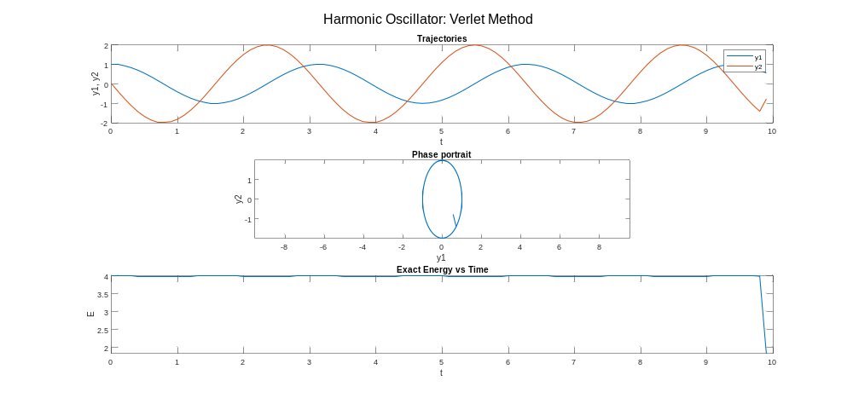
Figure 4. Simulation of a harmonic oscillator using the Verlet Method, with an approximate value of the last element in the $y_{2}$ vector.

MATLAB code: Verlet method
%% Verlet method
clc; clear; close all;

% Parameters
h = 0.1;
N = 500;
omega = 2;
y1 = zeros(1, N+1);
y2 = zeros(1, N+1);
E = zeros(1, N+1);
T = 0:h:(N*h);

% ICs
y1(1) = 1;
y2(1) = 0;

% Energy at t = 0
E(1) = (omega^2 * y1(1)^2 + y2(1)^2);

% for t = h = 0.1
y1(2) = y1(1) + h * y2(1) - (h^2 / 2) * omega^2 * y1(1);

for k = 2:N
y1(k+1) = 2 * y1(k) - y1(k-1) - h^2 * omega^2 * y1(k);
y2(k) = (y1(k+1) - y1(k-1)) / (2 * h);
E(k) = (omega^2 * y1(k)^2 + y2(k)^2);
end

figure;
subplot(3, 1, 1)
plot(T, y1, T, y2, "LineWidth", 1); xlabel('t'); ylabel('y1, y2'); title('Trajectories');
legend('y1', 'y2');

subplot(3, 1, 2)
plot(y1, y2, "LineWidth", 1); xlabel('y1'); ylabel('y2'); title('Phase portrait'); axis equal

subplot(3, 1, 3); plot(T, E, "LineWidth", 1); xlabel('t'); ylabel('E'); title('Exact Energy vs Time');
sgtitle('Harmonic Oscillator: Verlet Method')

Verlet's method version 2

%% Verlet method
clc; clear; close all;
% Parameters
h = 0.1;
N = 100;
omega = 2;
y1 = zeros(1, N);
y2 = zeros(1, N);
E = zeros(1, N);
% ICs
y1(1) = 1;
y2(1) = 0;
% Energy at t = 0
E(1) = (omega^2 * y1(1)^2 + y2(1)^2);
% for t = h = 0.1
y1(2) = y1(1) + h * y2(1) - (h^2 / 2) * omega^2 * y1(1);
for k = 2:N-1
y1(k+1) = 2 * y1(k) - y1(k-1) - h^2 * omega^2 * y1(k);
y2(k) = (y1(k+1) - y1(k-1)) / (2 * h);
E(k) = (omega^2 * y1(k)^2 + y2(k)^2);
end
y2(N) = (y1(N) - y1(N-1)) / (2 * h);
E(N) = (omega^2 * y1(N)^2 + y2(N)^2);
T = 0:h:((N-1)*h);
figure;
subplot(3, 1, 1)
plot(T, y1, T, y2, "LineWidth", 1); xlabel('t'); ylabel('y1, y2'); title('Trajectories');
legend('y1', 'y2');
subplot(3, 1, 2)
plot(y1, y2, "LineWidth", 1); xlabel('y1'); ylabel('y2'); title('Phase portrait'); axis equal
subplot(3, 1, 3); plot(T, E, "LineWidth", 1); xlabel('t'); ylabel('E'); title('Exact Energy vs Time');
sgtitle('Harmonic Oscillator: Verlet Method')

Explicit Euler (EE) & Implicit Euler (IE) methods
Figure 5 illustrates the simulation of a harmonic oscillator using Explicit Euler (EE) solution. Since the phase portrait does not form a closed loop, the system does not return to its initial conditions, implying an unstable system. This is further illustrated in the bottom plot, as energy diverges to infinity.

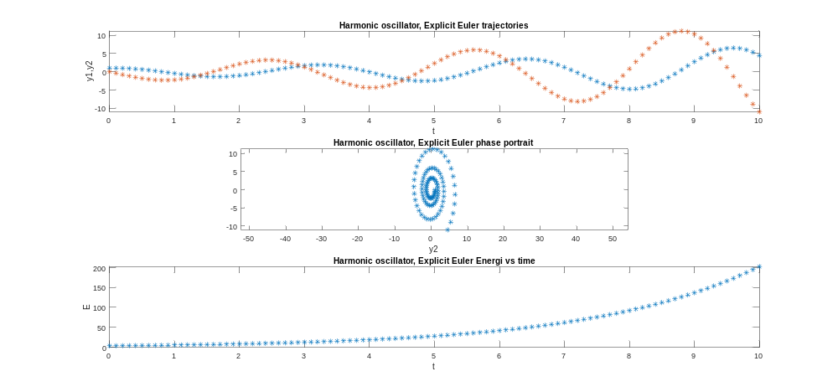
Figure 5. Simulation of a harmonic oscillator using the Explicit Euler method.

Figure 6 illustrates the simulation of a harmonic oscillator using Implicit Euler (IE) solution. Like EE, the implicit method does not return to its initial conditions, as shown in the phase portrait. However, the energy decreases to zero, rather than increasing to infinity, as seen in the bottom plot.

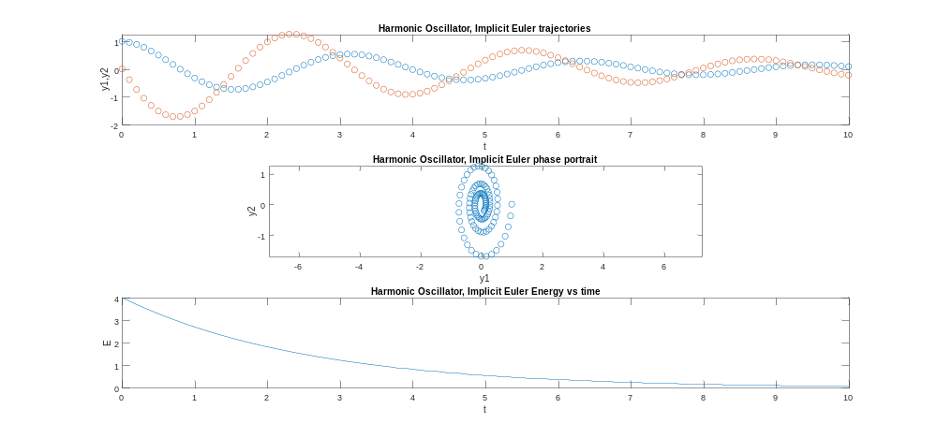
Figure 6. Simulation of a harmonic oscillator using the Implicit Euler method.

MATLAB code: Implicit Euler & Explicit method
%% Implicit Euler & Explicit Euler
y=[1,0]';t=0;
A=[0 1;-omega^2 0];
y=[1,0]';t=0;
Y=[y'];T=[t];E=[omega^2];
for k=1:N
y=y+h*A*y;
Y=[Y;y'];
t=t+h;
T=[T;t];
E=[E;omega^2*y(1)*y(1)+y(2)*y(2)];
end
Yexeul=Y;

figure;
subplot(3, 1, 1)
plot(T,Y,'*')
xlabel('t'),ylabel('y1,y2')
title('Harmonic oscillator, Explicit Euler trajectories')

subplot(3, 1, 2)
plot(Y(:,1),Y(:,2),'*')
axis('equal')
xlabel('y1'),xlabel('y2')
title('Harmonic oscillator, Explicit Euler phase portrait')

subplot(3, 1, 3)
plot(T,E,'*')
xlabel('t'),ylabel('E')
title('Harmonic oscillator, Explicit Euler Energi vs time')

y=[1,0]';t=0;
Y=[y'];T=[t];E=[omega^2];
for k=1:N
y=(eye(2)-h*A)\y;
Y=[Y;y'];
t=t+h;
T=[T;t];
E=[E;omega^2*y(1)*y(1)+y(2)*y(2)];
end
Yimeul=Y;

figure;
subplot(3, 1, 1)
plot(T,Y,'o')
xlabel('t'),ylabel('y1,y2')
title('Harmonic Oscillator, Implicit Euler trajectories')

subplot(3, 1, 2)
plot(Y(:,1),Y(:,2),'o')
axis('equal')
xlabel('y1'),ylabel('y2')
title('Harmonic Oscillator, Implicit Euler phase portrait')

subplot(3, 1, 3)
plot(T,E)
xlabel('t'),ylabel('E')
title('Harmonic Oscillator, Implicit Euler Energy vs time')

Analytic Solution

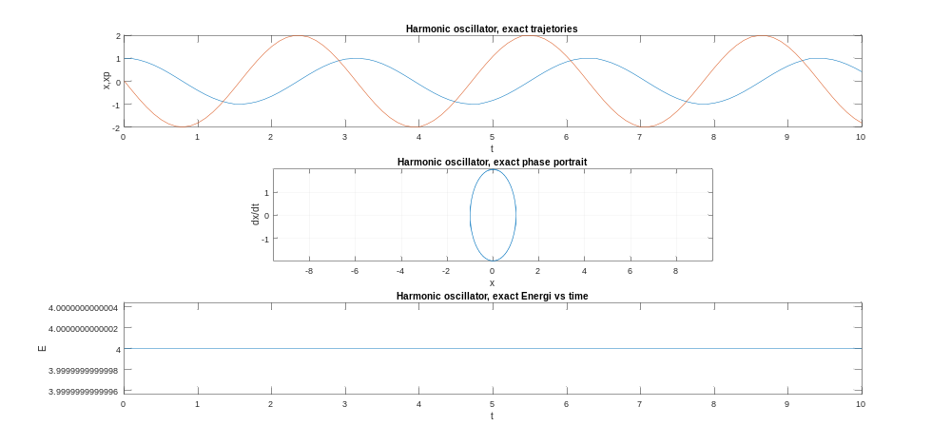
Figure 7. Simulation of a harmonic oscillator representing the analytical solution.

MATLAB code: Analytical method
%% Analytical Solution
%Numerical experiments with the harmonic oscillator
%Given d2x/dt2+omega^2 x=0, x(0)=1, dx/dt(0)=0

omega=2;
h=0.1;N=100;
t=[0:h:N*h];
x=cos(omega*t);
xp=-omega*sin(omega*t);
E=omega^2*(x.*x)+xp.*xp;

X=[x' xp'];

figure;
subplot(3, 1, 1)
plot(t,x,t,xp)
xlabel('t'),ylabel('x,xp')
title('Harmonic oscillator, exact trajetories')

subplot(3, 1, 2)
plot(x,xp)
axis('equal')
xlabel('x'),ylabel('dx/dt')
title('Harmonic oscillator, exact phase portrait')
grid

subplot(3, 1, 3)
plot(t,E)
xlabel('t')
ylabel('E')
title('Harmonic oscillator, exact Energi vs time')

